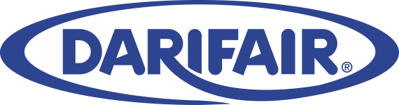

Darifair Foods, a premier food industry provider of high quality dairy and dairy alternative solutions has an exciting position open at the Corporate Headquarters in Jacksonville, Florida.

POSITION TITLE: Food Scientist – Dairy R&D

JOB DESCRIPTION AND PURPOSE:

We are seeking a highly motivated individual to join the Darifair Foods Research and Development team.

Responsible for research, development and design of new products and technologies with focus on new product development. Exploring new products and technology with focus on disruptive innovation. Lead product and process development activities to ensure successful scale up from lab to full production. Identify and develop innovative products and technologies that can drive Darifair’s business growth and establish new categories for business development. Utilize internal and external resources to secure and develop novel concepts and technologies. Support Culinary R&D team members with ingredient, stability, performance and manufacturing feasibility of all culinary products.

This is a junior level position.

This position reports to the Director of R&D.

REQUIRED EDUCATION AND EXPERIENCE:

- M.S. degree recent graduate, or B.S. degree in food science, food chemistry, chemical engineering or related field with a minimum of 3 years of industry experience in R&D / Innovation.

REQUIRED SKILLS:

Professional:

- Knowledge of food science, food chemistry, food processing and related fields.
- Basic knowledge of product development.
- Basic knowledge of raw materials.
- Knowledge and understanding of labeling regulations.
- Understanding and knowledge of FDA and USDA regulations.

Personal effectiveness:

- Highly motivated, critical thinker, goal oriented that easily adapts to change.
- Exceptional organizational skills and ability to manage multiple projects and assignments.
- Works proactively and adjusts to ever changing conditions with focus on delivering and driving results.
- Takes ownership and responsibility to assist the R&D process of the company.
- Makes time sensitive recommendations, communicates effectively, seeks others for input when needed, and protects the Darifair brand and customer base.
- Does not fold under pressure.
- Ability to work in a fast faced and high performing environment.
- Creates and maintains positive and productive work relationships internally with other departments and externally with our manufacturing facilities and customers.

Other:

- Ability to travel up to 50% of the time.
- Ability to work under hot and humid conditions.
- Ability to lift up to 50 lbs.
- Ability to work standing for extended periods of time.

COMPENSATION:

Income range should be appropriate as determined by experience, responsibilities and industry standards. Pay formula comprised of benefits including insurance, 401K, paid vacation and bonus opportunities.

Qualified candidates need to submit their resumes via email to luism@darifair.com with “Food Scientist position” on the subject line.

